University of Central Punjab
Faculty of Information Technology

Assignment 2

Course Title: Artificial Intelligence
Course Code: CSAL3243
Name | Registration#

Submission Requirements
- Format: The assignment must be handwritten and submitted as a single document (PDF or Word recommended) in softcopy.
- Integrity: This is an individual assignment. Any evidence of plagiarism or sharing of assignment will result in a zero grade.
- Due Date for Assignment is April 10th, 2026.
- NO LATE SUBMISSION.

CLO# | Course Learning Outcome (CLO) | Taxonomy Level | Mapping to PLO
CLO 2 | To design and implement AI applications that solve real-world problems. | C3 | PLO3

Total Marks =30

Question 1:
Find the shortest distance from Arad to Glurglu using Greedy Best First Search Algorithm in following map. Show all steps of state space and queue processing.
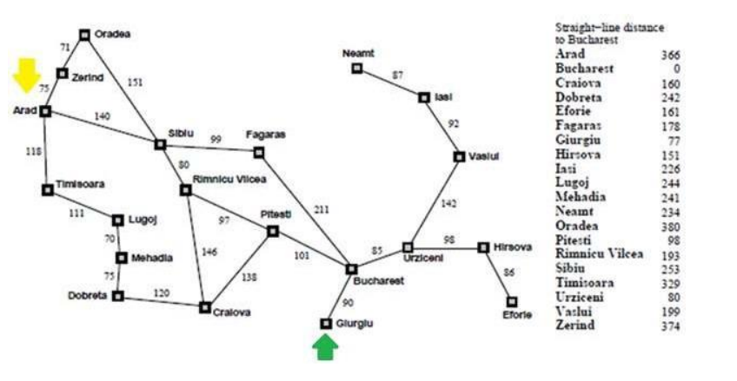
Question 2:
Perform Uniform Cost Search and the A* algorithm. Here we suppose that A is the initial node, and E is the target. The cost of each edge and the heuristic value of the each node are also given in the figure.
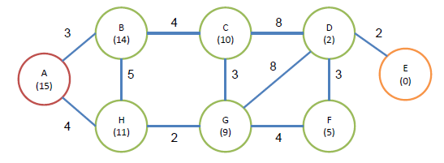
Question 3:
INFORMED SEARCH (A*): Trace the execution of the A* (A-Star) algorithm using the provided h(n) heuristic from LAHORE to ISLAMABAD.
- (a) Show the state of the Frontier priority queue at each step, listing the f(n) values for each expanded node.
- (b) Compare the final path and its total cost with your answer to Question 1.

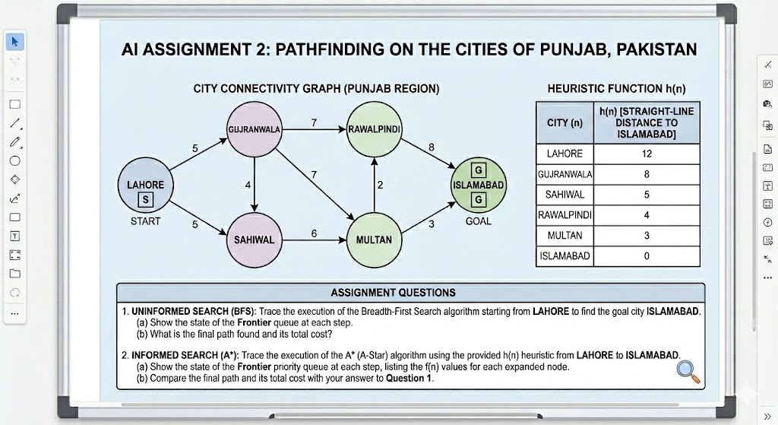

BEST OF LUCK

